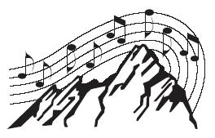

Boulder Chorale
Celebrating 40 years of excellence in education and performance

Yes! I want to contribute to THE BOULDER CHORALE

TOTAL GIFT: $____________________________

Name: __________________________________________________
(Please print your name as you would like it to appear in all BC acknowledgements and program listings.)

Address:________________________________________________

City/State/Zip:___________________________________________

Day Telephone:__________________________________________

Email Address (optional):___________________________________

Payment:

- My check for $___________
made payable to THE BOULDER CHORALE is enclosed.

- I would like to pledge my gift payable any time before June 1, 2006.
Please send me reminder(s) during the months of ____________.

- I would like my gift to remain anonymous.

The Boulder Chorale is a 501(c)3 non-profit organization. A donation receipt will be sent to you for your records.

Thank you for giving generously!

Please complete this form and return it to

The Boulder Chorale
Att: Fundraising
685 Inca Parkway
Boulder, CO 80303
Or call (303) 554.7692 and request additional Sponsorship information.

